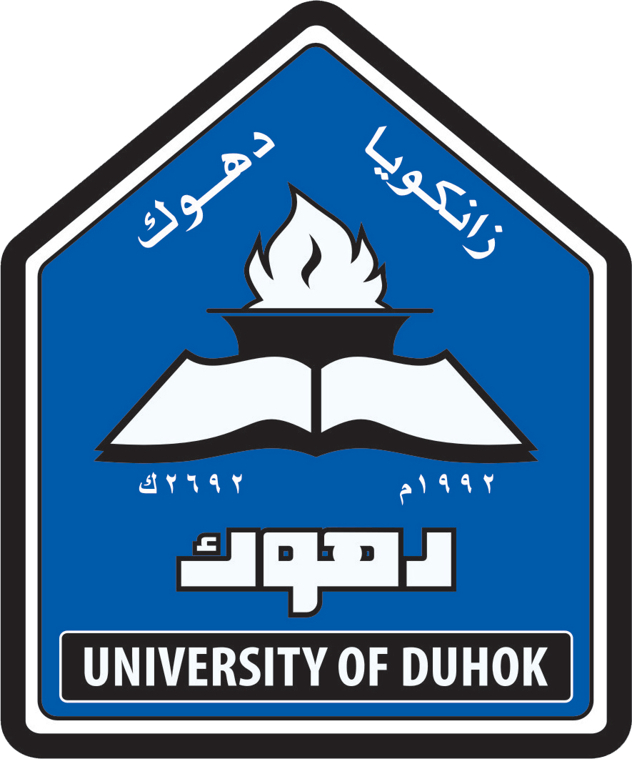
CURRICULUM VITA
Dr. Anees Mahmood Mudhir Barwary
Name : Anees Mahmood Mudhir
Date of birth: July 15th 1971
Marital Status: Married
Nationality: Iraqi (Kurdistan Region)
Languages : Kurdish,Arabic and English
Telephone/mobile: 009647507148272
E mail: anees.mahmood@uod.ac
QUALIFICATIONS
- B.D.S , College of Dentistry, Mosul University, Iraq 1996
- H.D, in conservative dentistry,College of Dentistry, University of Sulaimany, Iraq 2005
- M.Sc. in orthodontics, College of Dentistry, Hawler Medical University 2008
- Ph.D in orthodontics, College of Dentistry, Hawler Medical University 2014
MEMBERSHIPS
- Member in Iraqi Dental Association (1996-to date)
- Member in Kurdistan Dental Association (1996-to date)
DENTAL CONFERENCES
1.Participation in most annual dental conferences of Iraqi dental association and Colleges of dentistry in Iraq.
2.Worked with Help Age International as a dentist for the period of June 1999 to March 2000.
3.The first and second International Conference of Medical Sciences,Erbil,Iraqi (Kurdistan Region) 2009-2010.
4.2D lingual orthodontic training course(Kyungs indirect bracket from Dentos in lebanon 2009.
5.MIA(orthodontic microimplant AbsoAnchor system for comprehensive treatment) workshop in Lebanon 2010.
6.Participation in Iraqi dental reunion 1st and 2nd conferences 2011-2012
7.Participation in Conference and Exhibitions of Aeedc-Dubai 2009,2012,2014,2015 and 2016
8.First Dental Implantology Workshop,school of dentistry,Faculty of Medical Sciences,University of Duhok 2013
9.Second scientific national conference for Iraqi dental colleges,Baghdad 2013
10.First Scientific Meeting of Dentistry,Duhok Polytechnic University 2014
11.Training course on cosmetic dentistry by Tokuyama Company,Erbil,Iraq 2014

12.Advanced implant Education program from Dentium in Dubai 2016.
13.Asthetic indirect Veneers training course of Completion 3M Health Care Academy in Dubai 2016.
ا
SCIENTIFIC COURSES
- Participation in the Course in Teaching Methodes for Higher Education,Methods of Teaching,Training and Development Center,University of Duhok 2014

EMPLOYMENT HISTORY
1996 Duhok Specialized Dental Health Care Center (Rotatory training)
1997-2001 Duhok-Zaweta Health Center,Dental health care unit
2001-2003 Duhok Health director, Shaheedan Health Center,Dental health care unit (practitioner)
2003-2004 Duhok Health Director, Specialized Dental Health Care Center
2005 High Diploma student(conservative dentistry department), College of Dentistry, University of Sulaimany
2006-2008 M.Sc stude(orthodontic dentistry department)nt, College of Dentistry,Hawler Medical University
2008-2009 Specialist Dentist in orthodontic Department in Duhok Specialized Dental Health Center
2009-2014 Ph.D student(orthodontic department), College of Dentistry,Hawler Medical University
2014- To date of Department of POP, School of Dentistry, Faculty of Medical Sciences, Duhok University
1997- To date private clinic in Duhok City

THESIS AND PUBLICATIONS
Anees Mahmood M, Rafah H. Al Maroof and Fadhil Y. Jasim (2013). The role of local injection of TNF-α antagonist on orthodontic tooth movement in rabbits. Iraqi dental journal.Vol: 35,Issue:2.
Anees Mahmood M, Rafah H. Al Maroof and Fadhil Y. Jasim (2014). The role of infliximab local injection on orthodontic tooth movement in experimentally induced diabetic rabbits. Vol:36, Issue 1.

