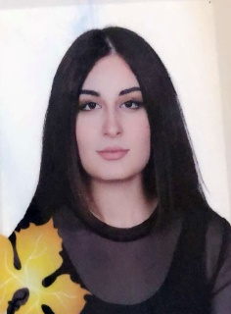
Rand Ali Saeed

Personal Information
Name: | Rand Ali Saeed | Address: | Nzarke
Place & Date of Birth | Duhok/19/11/1995 | Phone. No.
Marital Status: | Married | University E-mail | Rand.saeed@uod.ac

Employment Information
Profession: | Lecturer
Scientific Title & Acquiring Date: | Lecturer Assistant
Job Title:

Academic & Scientific Degrees
Degree | Bachelor | Master | PhD
University Name | University of Duhok | Yuzuncu yil university
Degree granting country | iraq | Turkey
Date of acquiring degree | 2017 | 2020
Title of Master Thesis | UN role in conflict resolution (case study:Cyprus)
Specialization | International Relations
Title of PhD Dissertation
Specialization

Teaching Expertise
From | To | Scientific Title | University Name | Given(taught)Subject Materials
2022

Managerial Expertise
Name of the University or Institution | To | From

Authored Translated Books
Date | Place of Publication | Name of the Book (title)

Scientific Researches
Date | Place of Publication | Research title

Essays
Date | Place of Publication | Name of the Essay (title)

Conferences & Workshops
Date | Type of Participation | Conference – WorkShop

Current Postgraduate (PhD, M.Sc., & Academic Diploma) Supervision

No. | Student Name | University – College and Department | official Order No. & Date | Thesis Title
1
2
3
4

Syndicate or Organizations Membership
Kind of Membarship | Name of Organization or Syndicate

Academic Network

Website Name | Link
Google Scholar
Research Gate

